Lab#4 Create a static web page of your college which includes information regarding Vision, Mission, Program specific outcomes, Courses Offered, Image gallery of events, Top Recruiters using HTML and CSS.

TAGS USED | DESCRIPTION
<!DOCTYPE html> | Declares the document as an HTML5 document.
<html> | Root element of the HTML document.
<head> | Contains metadata and information about the HTML document.
<meta> | Defines metadata for the HTML document.
<link> | Links an external CSS file to the HTML document.
<title> | Specifies the title shown in the browser tab.
<body> | Contains all visible content of the webpage.
<header> | Defines the header section of the webpage.
<h1> | Defines the main heading.
<h2> | Defines a secondary heading.
<nav> | Defines the navigation section.
<a> | Defines hyperlinks to different sections of the webpage.
<main> | Defines the main content of the webpage.
<section> | Defines separate sections of content.
<h3> | Defines section headings.
<p> | Defines a paragraph.
<ul> | Defines an unordered (bulleted) list.
<ol> | Defines an ordered (numbered) list.
<li> | Defines an item in a list.
<footer> | Defines the footer section of the webpage.

ATTRIBUTES USED | TAG | DESCRIPTION
lang="en" | <html> | Specifies that the language of the document is English.
charset="UTF-8" | <meta> | Specifies UTF-8 character encoding.
name="viewport" | <meta> | Defines viewport settings for responsive webpages.
content="width=device-width, initial-scale=1.0" | <meta> | Makes the webpage responsive on different screen sizes.
rel="stylesheet" | <link> | Specifies that the linked file is a stylesheet.
href="style.css" | <link> | Specifies the path of the external CSS file.
href="#vision" | <a> | Links to the Vision section.
href="#mission" | <a> | Links to the Mission section.
href="#pso" | <a> | Links to the PSOs section.
href="#courses" | <a> | Links to the Courses section.
href="#recruiters" | <a> | Links to the Recruiters section.
id="vision" | <section> | Gives the Vision section a unique identifier.
id="mission" | <section> | Gives the Mission section a unique identifier.
id="pso" | <section> | Gives the PSOs section a unique identifier.
id="courses" | <section> | Gives the Courses section a unique identifier.
id="recruiters" | <section> | Gives the Recruiters section a unique identifier.

Final Outcome:

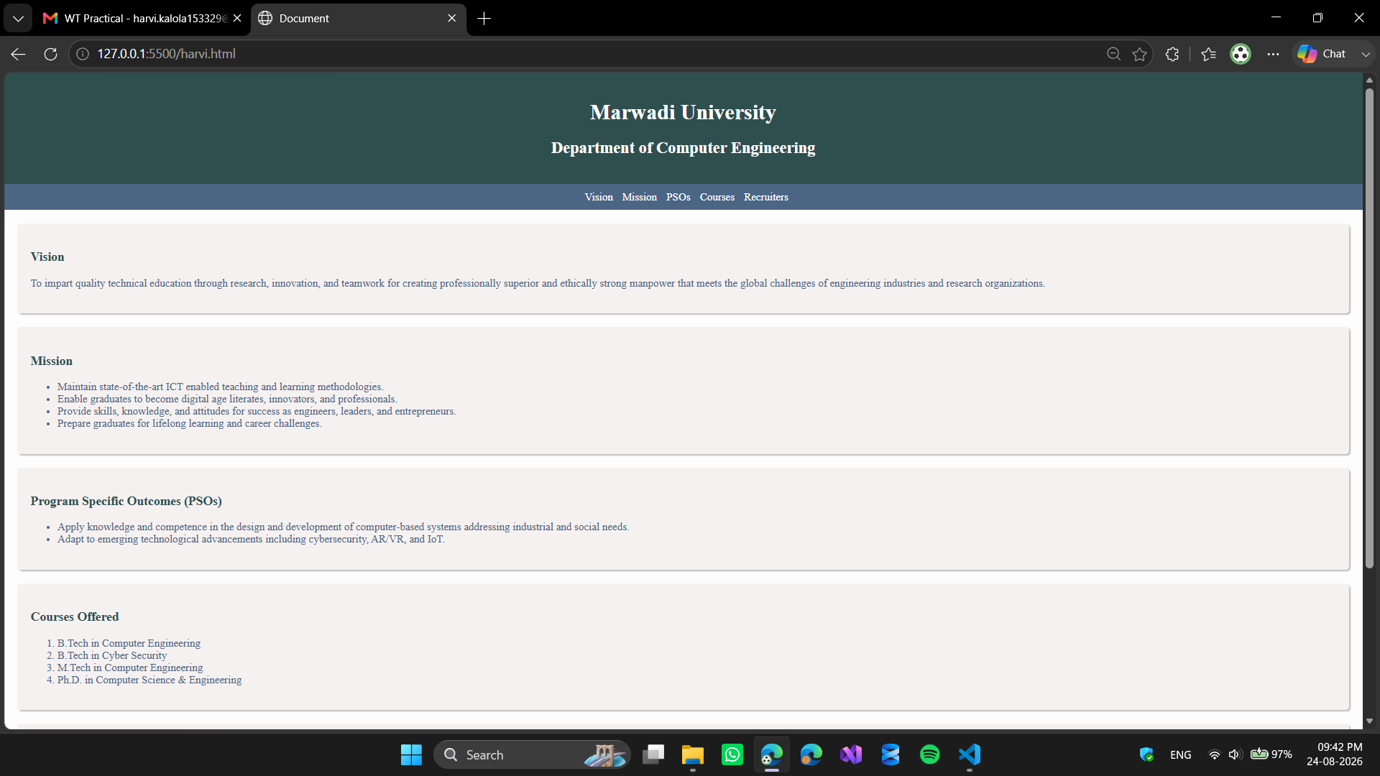
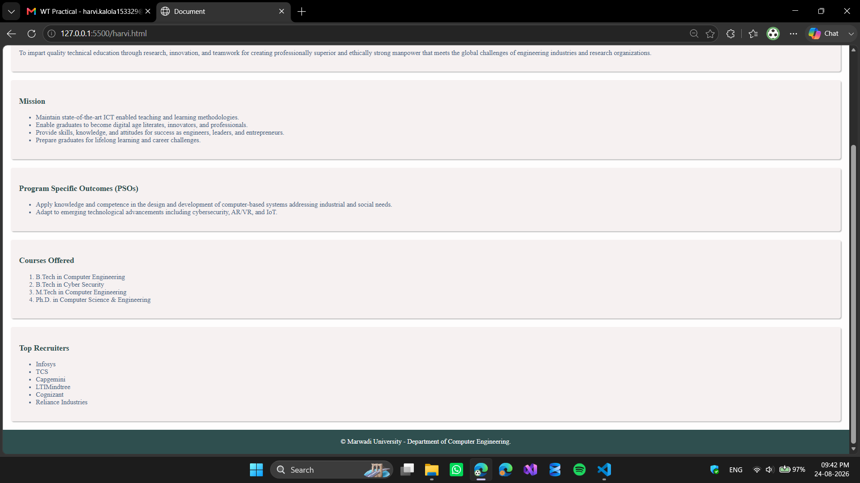
Code Snippet: index.html

<!DOCTYPE html>
<html lang="en">
<head>
<meta charset="UTF-8">
<meta name="viewport" content="width=device-width, initial-scale=1.0">
<link rel="stylesheet" href="style.css">
<title>Document</title>
</head>
<body>
<header>
<h1>Marwadi University</h1>
<h2>Department of Computer Engineering</h2>
</header>
<nav>
<a href="#vision">Vision</a>
<a href="#mission">Mission</a>
<a href="#pso">PSOs</a>
<a href="#courses">Courses</a>
<a href="#recruiters">Recruiters</a>
</nav>
<main>
<section id="vision">
<h3>Vision</h3>
<p>To impart quality technical education through research, innovation, and teamwork for creating professionally superior and ethically strong manpower that meets the global challenges of engineering industries and research organizations.</p>
</section>
<section id="mission">
<h3>Mission</h3>
<ul>
<li>Maintain state-of-the-art ICT enabled teaching and learning methodologies.</li>
<li>Enable graduates to become digital age literates, innovators, and professionals.</li>
<li>Provide skills, knowledge, and attitudes for success as engineers, leaders, and entrepreneurs.</li>
<li>Prepare graduates for lifelong learning and career challenges.</li>
</ul>
</section>
<section id="pso">
<h3>Program Specific Outcomes (PSOs)</h3>
<ul>
<li>Apply knowledge and competence in the design and development of computer-based systems addressing industrial and social needs.</li>
<li>Adapt to emerging technological advancements including cybersecurity, AR/VR, and IoT.</li>
</ul>
</section>
<section id="courses">
<h3>Courses Offered</h3>
<ol>
<li>B.Tech in Computer Engineering</li>
<li>B.Tech in Cyber Security</li>
<li>M.Tech in Computer Engineering</li>
<li>Ph.D. in Computer Science & Engineering</li>
</ol>
</section>
<section id="recruiters">
<h3>Top Recruiters</h3>
<ul>
<li>Infosys</li>
<li>TCS</li>
<li>Capgemini</li>
<li>LTIMindtree</li>
<li>Cognizant</li>
<li>Reliance Industries</li>
</ul>
</section>
</main>
<footer>
&copy; Marwadi University - Department of Computer Engineering.
</footer>
</body>
</html>

Code Snippet: style.css
body {
background-color: #fefdfd;
margin: 0px;
}

header {
background-color: #2f4f4f;
color: white;
text-align: center;
padding: 20px;
}

nav {
background-color: #4b6584;
text-align: center;
padding: 5px;
}

nav a {
color: white;
text-decoration: none;
margin-left: 10px;
}
a:hover {
color: #deecfd;
text-decoration: underline;
}

section {
background-color: #f6f1f1;
color: #4b6584;
padding: 20px;
margin: 20px;
border-radius: 5px;
box-shadow: 2px 2px 2px #bdbdbd;
}

h3 {
color: #2f4f4f;
}

footer {
text-align: center;
background-color: #2f4f4f;
color: white;
padding: 20px;
}

